**Online Event Booking System Project** will be implemented in ASP.Net MVC. This is a web application for online event ticket booking. Any user can access this system through website at any time anywhere and buy any tickets without going to [booking](https://mcabcaprojects.com/121-online-movie-ticket-booking-system-project/) counter.

**Project abstract**

Introduction to Online event Ticket Booking System

* Online event ticket booking system is basically made for providing the customers an anytime and anywhere service for booking any event tickets and providing information about the event and their schedule online.
* Admin can use Online Event Ticket Booking System Project to insert and delete data such as event description, evet schedule which will update the related webpage and will be accessible by the customers.
* Online Event Ticket Booking System provide another way for the customers to buy event ticket. This system reduces work load on customers, it is an automatic ticket booking system.
* This system is basically aimed to provide complete information of the event and schedule to the customer, according to which he can book the tickets.
* Users can see pictorial view of all the available events and book their seat.

**System users-**

1. The Visitors or the Registered users

2. The admin (Who is responsible to update the portal)

**Role:**

### *Visitor:*

* Can browse available events - timings, rate
* Register

#### Registered user:

* Login/Logout
* Can browse available events - timings, rate
* Can view cart
* Book the tickets for an event - make payment
* cancel a booking within stipulated time

#### Admin

* Admin is the main backbone for this portal.
* Admin is responsible for adding , editing and deleting an event.
* He can also view the number of users that are registered to the web portal.
* See all booking done/cancelled

**Online Event Booking system features**

* Customer registration
* User Login
* Admin Login
* Admin CRUD events
* Events display list (for both admin and user)
* Event Booking by users (create/delete)
* Selected events display list (only for user)
* Book ticket
* Booking confirmation on UI
* Booking confirmation via Email/Phone
* View all the bookings (for admin)

Background Flows:

* Send booking confirmation to registered user via mails/phone numbers

Technology (Language) used to develop this Sotware

* ASP.Net MVC (C#)
* EntityFramework
* SQL
* CSS
* Javascript

**General Requirements:**

* 1 Event can be running on multiple locations
* 1 Event can have multiple shows at a single locations
* 1 Location can have multiple events
* Consider one location has one screen/stage
* Events can be movies, stand-up, musical, theatre

**Non-functional requirement:**

**1. Security -**

The system uses SSL (secured socket layer) in all transactions that include any confidential customer information.

The system must automatically log out all customers after a period of inactivity.

The system should not leave any cookies on the customer’s computer containing the user’s password.

The system’s back-end servers shall only be accessible to authenticated administrators.

Sensitive data will be encrypted before being sent over insecure connections like the internet.

**4. Maintainability -**

A commercial database is used for maintaining the database and the application server takes care of the site. In case of a failure, a re-initialization of the program will be done. Also, the software design is being done with modularity in mind so that maintainability can be done efficiently.

**5. Portability -**

The application is HTML and scripting language based. So The end-user part is fully portable and any system using any web browser should be able to use the features of the system, including any hardware platform that is available or will be available in the future.

An end-user is using this system on any OS; either it is Windows or Linux.

The system shall run on PC, Laptops, etc.

**6. Accessibility -**

The system will be a web-based application it is going to be accessible on the web browser.

**7. Back up -**

We will take a backup in our system database. In order to enable the administrator and the user to access the data from our system!

**8. Performance -**

The product shall be based on web and has to be run from a web server.

The product shall take initial load time depending on internet connection strength which also depends on the media from which the product is run.

The performance shall depend upon hardware components of the client/customer

**9. Accessibility -**

The system shall provide handicap access.

**10. Supportability -**

The source code developed for this system shall be maintained in GIT repository .

Link :-

**Functional requirement:**

**1. Registration -**

If a customer wants to book the ticket then he/she must be registered, an unregistered user can’t book the ticket.

**2. Login -**

Customer logins to the system by entering valid user id and password for booking the ticket.

**3. View Events -**

The system shall have a page where user can view list of all available events (event, stand up shows, musical, theatre). Customer or visitor can view events name, date, time, location and venue.

**5.Ticket cancelling -**

The customer shall be given an option to cancel ticket one hour before the event with some fine.

**6. Payment -**

There will be a dummy payment system.

**7. Logout -**

After the payment or browse the event, the customer will log out.

**8. Send booking notification -**

After booking, the system can generate a confirmation message sent to the customer’s Email-address

**9. Add events -**

The system shall have a feature for admin to add events and their details.

**10. Remove events -**

The system shall have a feature for admin to remove events.

**Stakeholder requirement:**

1. The user should be able to view the list of events which are running near to his location (based on GPS).
2. The user should be able to book the seat as per his choice in the hall.
3. The user should have different options for payment.
4. The system shall allow the user to create a profile and set his credential.
5. The system shall authenticate user credentials to view the profile.
6. The system shall send an order confirmation to the user through email.

**Use case requirement:**

**1. Purchase advanced tickets -**

Customer requests to view Showings for a DateTime. The system retrieves a list of Showings, including DateTime, Film Title for each Showing. The customer selects an event.

**2. Collect tickets -**

Customers provide Payment Card Details. After payment, the system prints Tickets which are Booked.

**3. Add Events -**

The cinema manager adds details of a new film. Film details include Title, Age Rating, Duration, and short trailer description.

**4. Delete Events -**

The admin delete details of an obsolete film. The film can only be deleted if there are no showings allocated to it.

**7. Cancel events -**

The user can requests to delete a booking.

**8. Login -**

The system user is asked to log in with their credentials.

**9. Logout -**

The system is automatically logged out after a certain period.

**10. Registration -**

New users register themselves to get identified and get login credentials.

Use case diagrams:-

*Admin:- Administrator is the user of the system. He is responsible for:-*

1. Admin login
2. Adding event to the event list
3. Adding event details for the events
4. View all booking

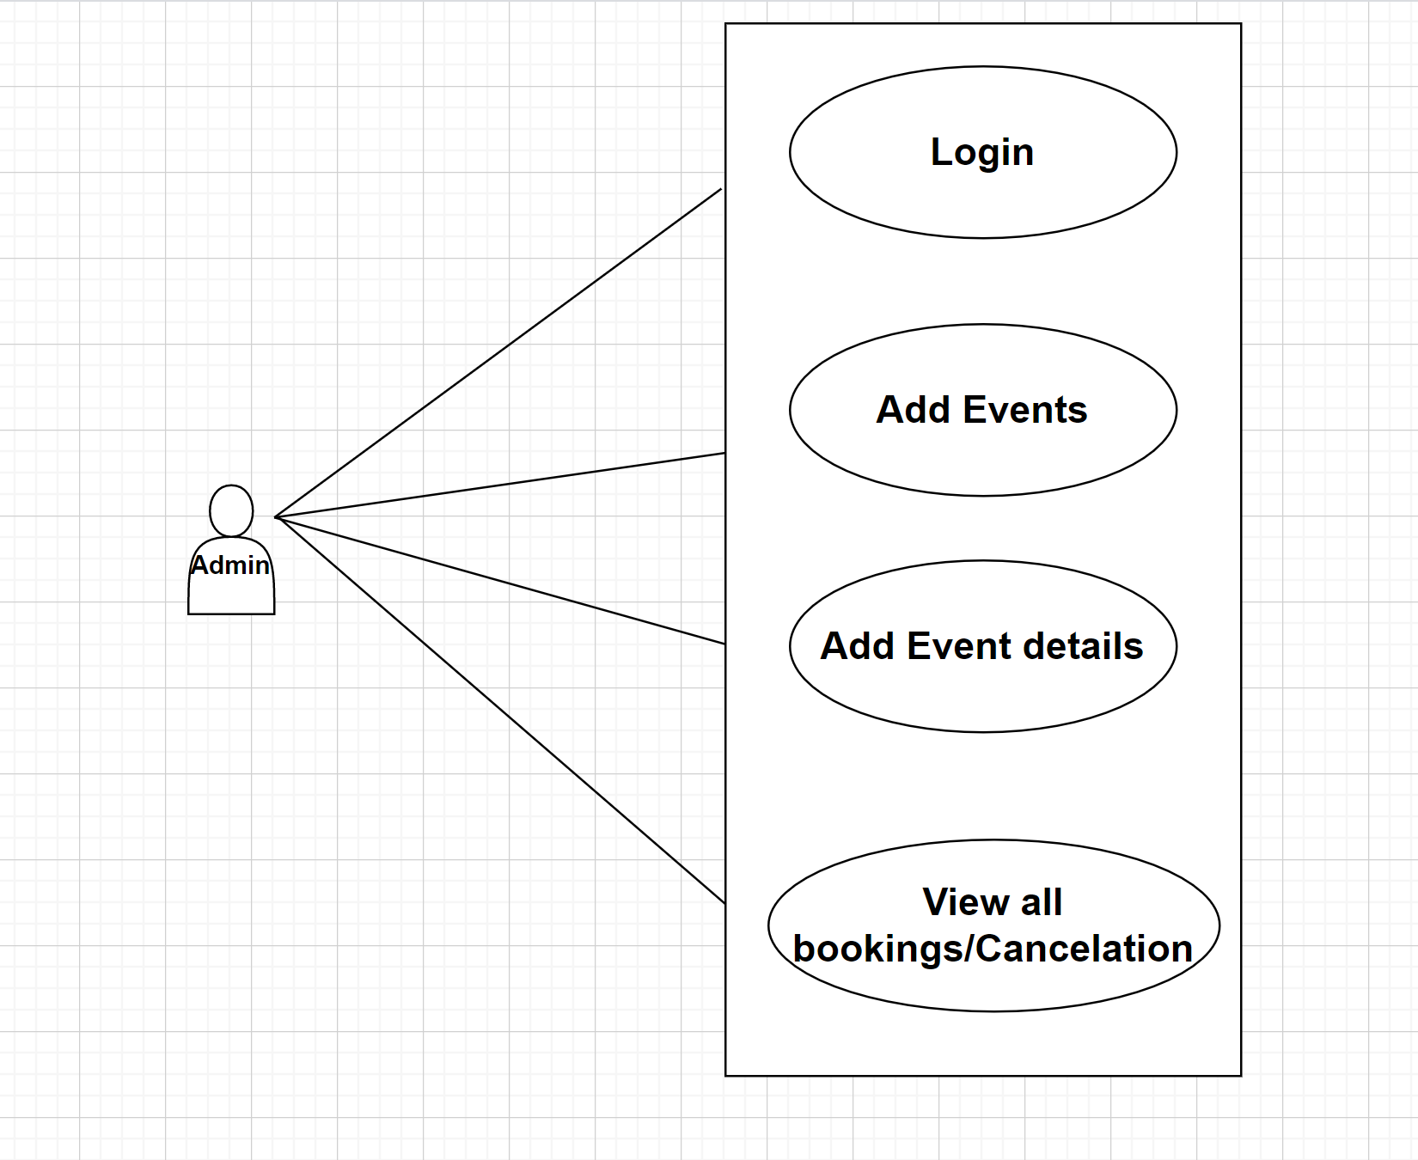

2. *Registered users*

Registered users ae responsible for:-

* Login/Logout
* Can browse available events - timings, rate
* Book the tickets for an event - make payment
* View the cart
* Cancel booking

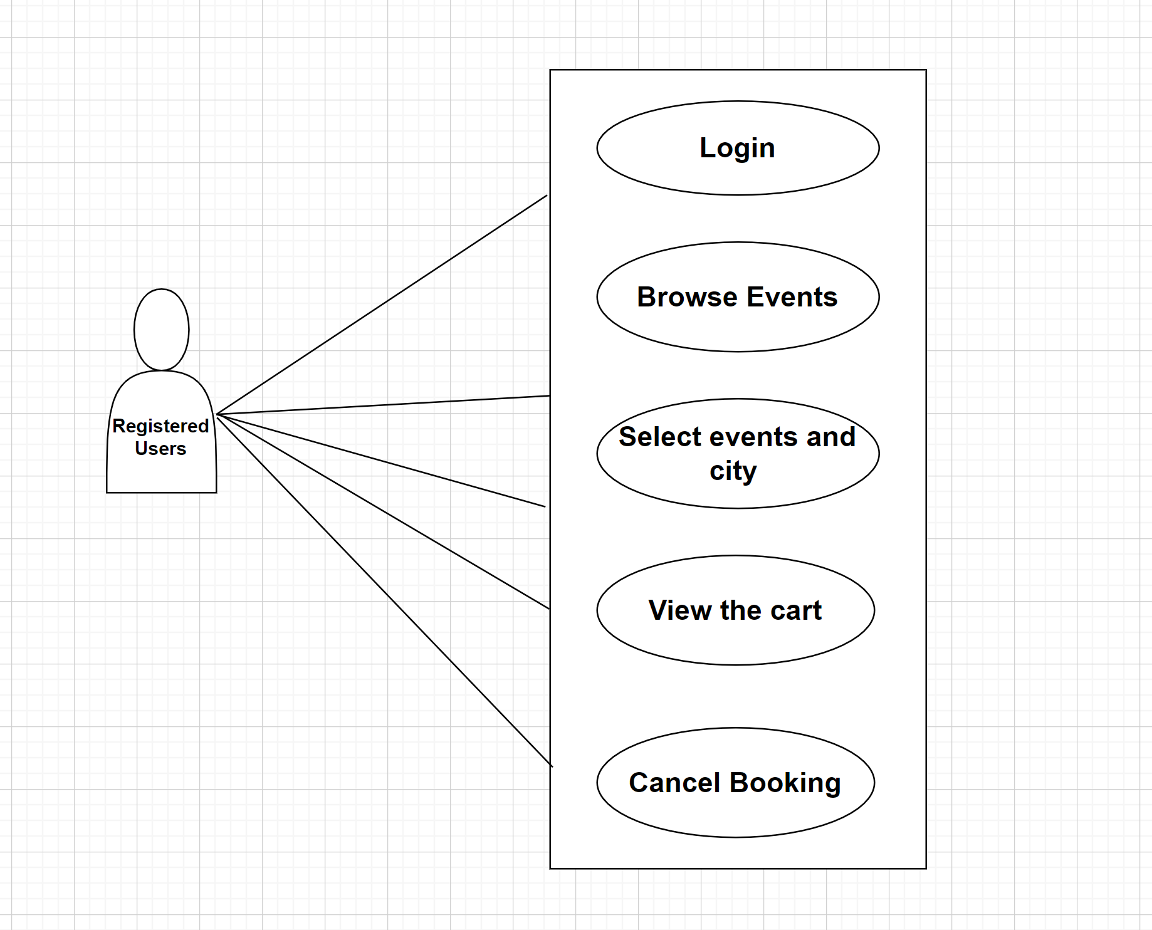

3. *Unregistered users*

Unregistered users are responsible for

* Can browse available events - timings, rate
* Register

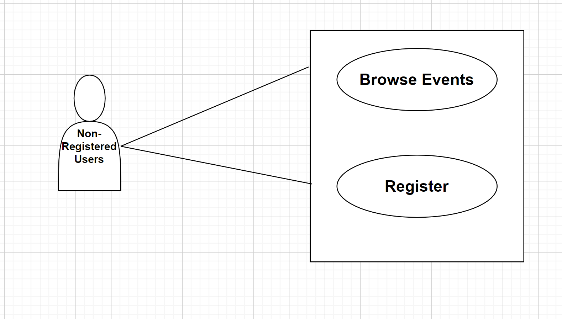

Class Diagram:-

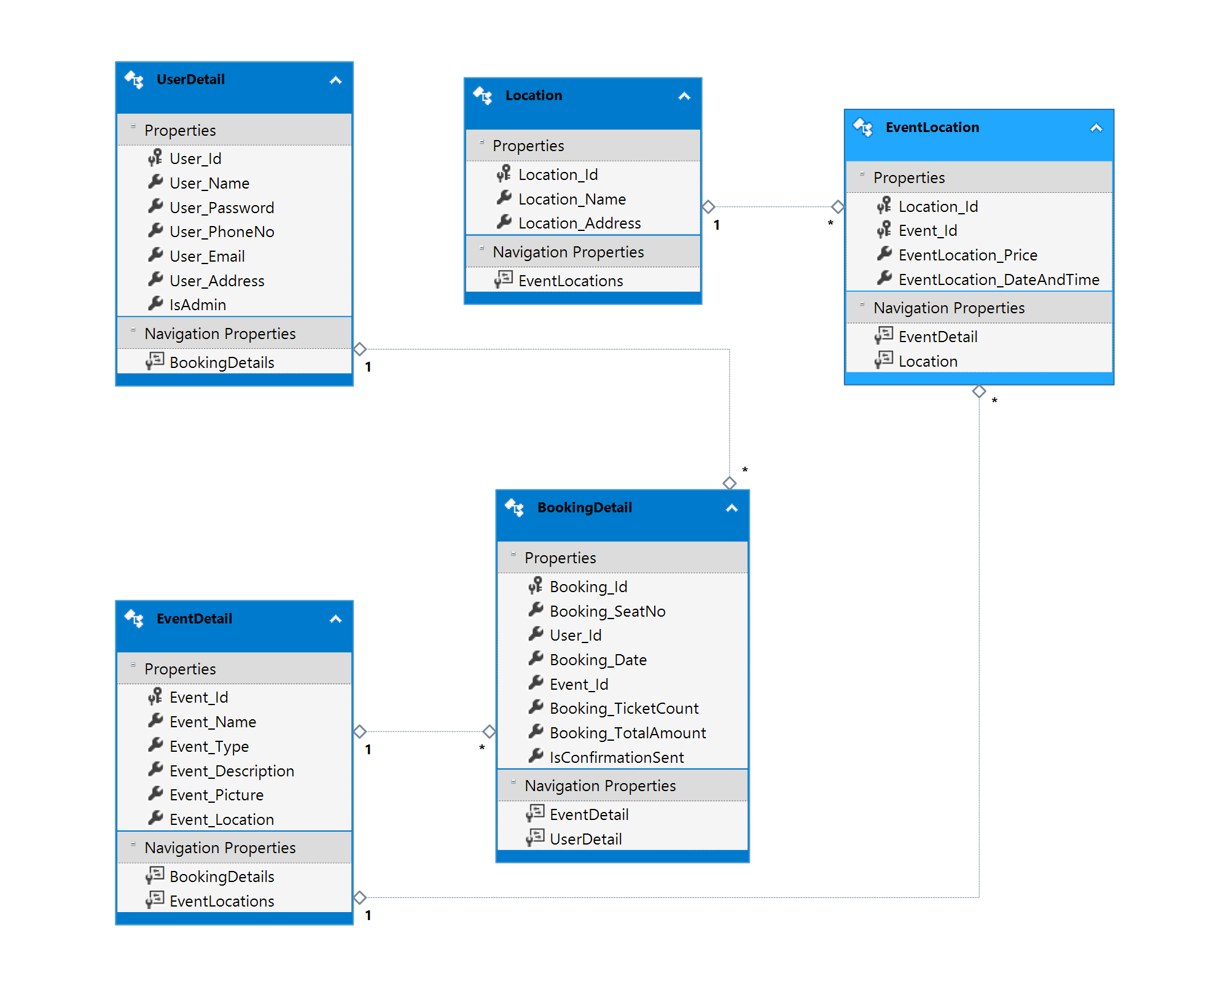

Sequence diagram:-

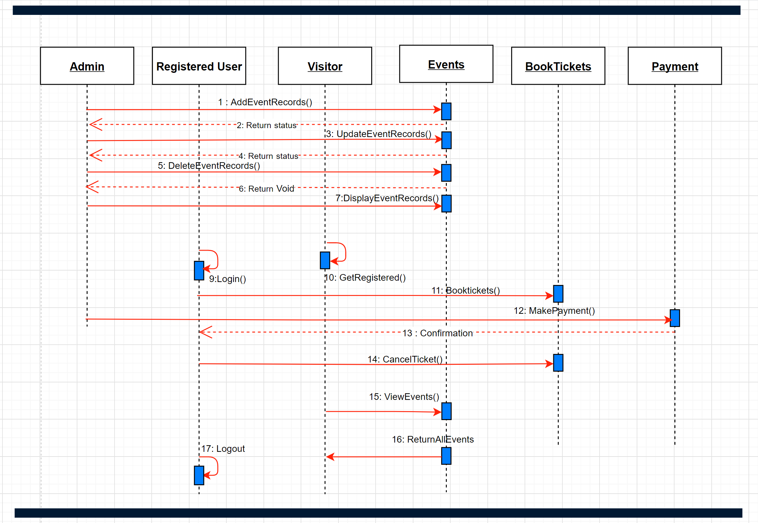

2. High level entities and process flow online event ticket booking system:-

* Managing all the users
* Managing all the events
* Managing all the tickets
* Managing all the bookings
* Managing all the seats
* Managing all the showtime

Zero level DFD

